CHAPTER 2
MOTION ALONG A STRAIGHT LINE
Discussion Questions
Q2.1 The speedometer measures the magnitude of the instantaneous velocity, the speed. It does not measure velocity because it does not measure direction.

Q2.2 Graph (d) . The dots represent the insect’s position as a function of time. If the photographs are taken at equal spaced time intervals, then the displacement in successive intervals is increasing and this means the speed is increasing. Therefore, graphs (a) and (e) can be ruled out. Graph (b) shows decreasing acceleration so would correspond to the speed approaching a constant value, which is not what the photographs show. Graph (c) shows motion in the negative x-direction, which is not the case. This leaves graph (d). This graph shows velocity in the positive x-direction and increasing speed. This is consistent with the photographs.

Q2.3 The answer to the first question is yes. If the object is initially moving and the acceleration direction is opposite to the velocity direction, then the object slows down, stops for an instant and then starts to move in the opposite direction with increasing speed. An example is an object thrown straight up into the air. Gravity gives the object a constant downward acceleration. The object travels upward, stops at its maximum height and then moves downward. The answer to the second question is no. After the first reversal of the direction of travel the velocity and acceleration are then in the same direction. The object continues moving in the second direction with increasing speed.

Q2.4 Average velocity equals instantaneous velocity when the speed is constant and motion is in a straight line.

Q2.5 a) Yes. For an object to be slowing down, all that is required is that the acceleration be nonzero and for the velocity and acceleration to be in opposite directions. The magnitude of the acceleration determines the rate at which the speed is changing. b) Yes. For an object to be speeding up, all that is required is that the acceleration be nonzero and for the velocity and acceleration to be in the same direction. The magnitude of the acceleration determines the rate at which the speed is changing. But for any nonzero acceleration the speed is increasing when the velocity and acceleration are in the same direction.

Q2.6 Average velocity is the magnitude of the displacement divided by the time interval. Average speed is the distance traveled divided by the time interval. Displacement equals the distance traveled when the motion is in the same direction for the entire time interval, and therefore this is when average velocity equals average speed.

Q2.7 For the same time interval they have displacements of equal magnitude but opposite directions, so their average velocities are in opposite directions. One average velocity vector is the negative of the other.

Q2.8 If in the next time interval the second car had pulled ahead of the first, then the speed of the second car was greater. The second car could also be observed to be alongside a pedestrian standing at the curb, but that does not mean the pedestrian was speeding.
Q2.9 The answer to the first question is no. Average velocity is displacement divided by the time interval. If the displacement is zero, then the average velocity must be zero. The answer to the second question is yes. Zero displacement means the object has returned to its starting point, but its speed at that point need not be zero. See Fig. DQ2.9.
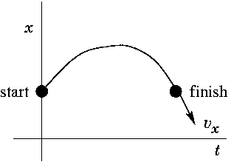
Figure DQ2.9

Q2.10 Zero acceleration means constant velocity, so the velocity could be constant but not zero. See Fig. DQ2.10. An example is a car traveling at constant speed in a straight line.

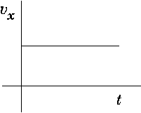
Figure DQ2.10

Q2.11 No. Average acceleration refers to an interval of time and if the velocity is zero throughout that interval, the average acceleration for that time interval is zero. But yes, you can have zero velocity and nonzero acceleration at one instant of time. For example, in Fig. DQ2.11, 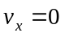when the graph crosses the time axis but the acceleration is the nonzero slope of the line. An example is an object thrown straight up into the air. At its maximum height its velocity is zero but its acceleration is downward.

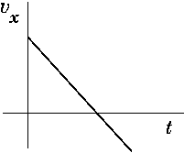
Figure DQ2.11

Q2.12 Yes. When the velocity and acceleration are in opposite directions the object is slowing down.

Q2.13 (a) Two possible x-t graphs for the motion of the truck are sketched in Fig. DQ2.13.
(b) Yes, the displacement is 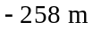and the time interval is 9.0 s, no matter what path the truck takes between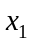and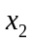. The average velocity is the displacement divided by the time interval.
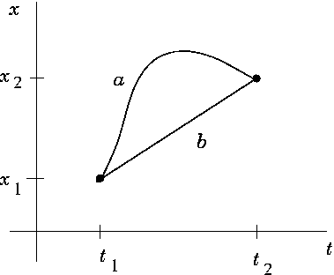
Figure DQ2.13
Q2.14 This is true only when the acceleration is constant. The average velocity is defined to be the displacement divided by the time interval. If the acceleration is not constant, objects can have the same initial and final velocities but different displacements and therefore different average velocities.

Q2.15 It is greater while the ball is being thrown. While being thrown, the ball accelerates from rest to velocity 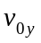while traveling a distance less than your height. After it leaves your hand, it slows from to zero at the maximum height, while traveling a distance much greater than your height. Eq.(2.13) says that 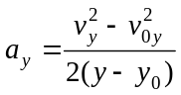. Larger 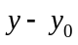 means smaller 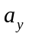.

Q2.16 (a) Eq.(2.13): 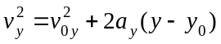. When an object returns to the release point, 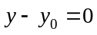. Eq.(2.13) then gives 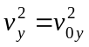 and 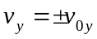.
(b) 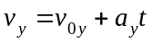. At the highest point 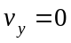, so 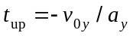. At the end of the motion, when the object has returned to the release point, we have shown in (i) that 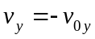,
so 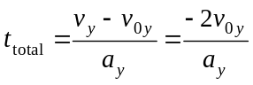 and 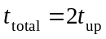.

Q2.17 The distance between adjacent drops will increase. The drops have the downward acceleration 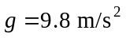of a free-falling object. Therefore, their speed is continually increasing and the distance one drop travels in each successive 1.0 s time interval increases. A given drop has fallen for 1.0 s longer than the next drop released after it, so the additional distance it has fallen increases as they fall. Mathematically, let t be the time the second drop has fallen, so the first drop has fallen for time 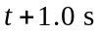. The distance between these two drops then is
. The separation 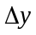 increases as t increases.

Q2.18 Yes. Consider very small time intervals during which the acceleration doesn’t have time to change very much, so can be assumed to be constant. Calculate 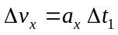, for a very small time interval, starting at 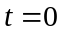. Then 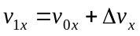. Since the acceleration is assumed constant for the small time interval, 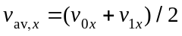 and 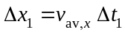. Then the position at the end of the interval is 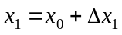. Repeat the calculation for the next small time interval 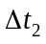: 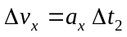, 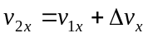, 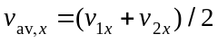, 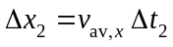. Repeat for successive small time intervals.

Q2.19 In the absence of air resistance, the first ball rises to its maximum height and then returns to the level of the top of the building. When it returns to the height from which it was thrown, at the top of the building, it is moving downward with speed 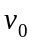. The rest of its motion is the same as for the second ball. (a) Since the last part of the motion of the first ball starts with it moving downward with speed from the top of the building, the two balls have the same speed just before they reach the ground. (b) The second ball reaches the ground first, since the first ball has to move up and then down before repeating the motion of the second ball. (c) Displacement is final position minus initial position. Both balls start at the top of the building and end up at the ground. So they have the same displacement. (d) The first ball has traveled a greater distance.

Q2.20 Let the 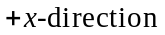be east. The average velocity is the displacement divided by the time interval. The first 120.0 m displacement requires a time of . The second 120.0 m displacement requires a time of . The average velocity is 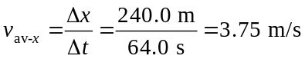. This is less than 4.00 m/s since you spend more time running at 3.00 m/s than at 5.00 m/s.

Q2.21 At the highest point the object instantaneously has zero speed. But its velocity is continually changing, at a constant rate. Acceleration measures the rate of change of velocity. For example, in Fig. 2.25b when the graph crosses the time axis it still has a constant slope that corresponds to the acceleration. Also note the comments in part (d) of the solution to Example 2.7.

Q2.22 For an object released from rest and then moving downward in free-fall, its downward displacement from its initial position of 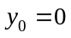is given by 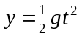. To increase y by a factor of 3, increase t by a factor of 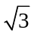. You can also see this by letting Y be the original height, so 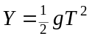. Let the new height be 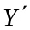 and the corresponding time be 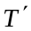, so 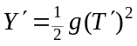. But 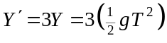, so 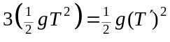 and 

